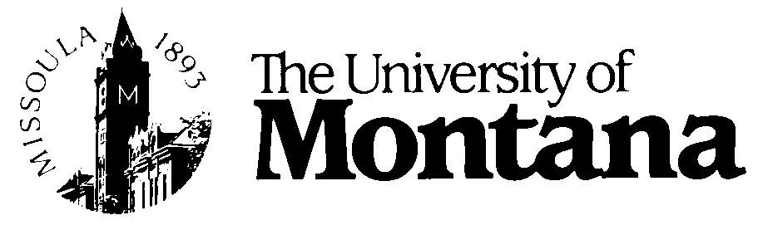

Faculty and Staff Awards

NOMINATION FORM

** All nominations must include this form. **
This form does not take the place of nomination letters, curricula vitae, or other materials required for nomination (see http://umt.edu/president/events for individual award requirements). Please feel free to attach additional pages to answer the questions below.

Name of Award: ______________________________________________________________

Nominee: ____________________________________________________________________

Job Title: ____________________________________________________________________

Department: __________________________________________________________________

School/College: ________________________________________________________________

Years of Service at UM: _____ (Please contact Human Resources if you aren’t sure)

Name and Title of Nominator: _____________________________________________________

Please provide 2-3 sentences about why you feel this nominee deserves the award (for use the Award Ceremony Program should your nominee win):

Special achievements and/or activities that led to nomination (please include dates):

Publications (list up to three; please include dates):

Awards and professional recognition (please include dates):

Other professional affiliations and activities:

